When I found *Dr. Kermit W. Sprocket’s Build Your Own Robot Kit* at a yard sale, I had no idea it would ultimately lead to me saving the world from an alien invasion.

I just liked the idea of building a robot.

I also liked the price. Three bucks.



It was one of those early September Saturdays, the kind that felt like the last gasp of summer.

The sun was warm but the air was cool, and the neighborhood smelled faintly of fresh-cut grass.

The Mendelsons, who lived four houses over, were having a yard sale, and I was there with my parents, rummaging through the relics of some other family’s past.

Baby clothes, coffee mugs, dusty exercise equipment, board games missing half their pieces, DVDs nobody had a player for anymore, old puzzles, old books, old puzzle books, a terrifying ceramic clown lamp, and…

…a build your own robot kit?

I found it tucked under a table, in a faded cardboard box. I knelt down, slid the box out, and opened the lid.

Inside, the parts were jumbled in a way that made it instantly obvious this kit had been torn through, used, at least a little, and repackaged using materials from the kitchen pantry. There were a couple of wheels, a plastic…something (the robot’s body, maybe?), a white plastic block that had a grid of tiny pinholes on its face, a bunch of electrical components, some more electrical components in a sandwich bag, a coil of wires wrapped in a rubber band, a Lego, a very strange pink plastic robot figurine of some sort, and a booklet titled HOW TO BUILD YOUR FIRST ROBOT—printed in the same cheerful font that was on the box.



I strongly suspected at least a few pieces were missing.

“Find something?” asked the woman running the sale.

“Yeah,” I said, holding up the box.

She smiled. “My son tried to build that years ago. Didn’t get very far. Tell you what. The price says three, but you can have it for two.”

Sold.

An hour later I was on my bike, pedaling straight to Grandpa’s workshop, also known as The Fortress.

Grandpa’s workshop was a squat concrete building that, years ago, before I was born, used to be some kind of store or something. Apparently the store got robbed, then the owners spent big bucks to put metal bars over the window and an iron gate around the whole place (which was why it always looked like a fortress to me), and then the store went out of business anyway. That’s when Grandpa bought the building and filled it with all his old tools, machines, workbenches, half-finished inventions, and about a million strange objects whose purpose only he knew.

I rang the buzzer (which sounded like a doorbell mixed with an air-raid siren). A minute later, Grandpa appeared. He was wearing his usual uniform of a button-down work shirt and blue jeans. He was wiping his hands with a towel. He had a smudge of machine grease on his cheek.

“What’ve you got there?” he said, eyeing the box under my arm.

“I found this at a garage sale,” I said, grinning. “Dr. Kermit W. Sprocket’s Robot Kit. Two bucks.”

“Two bucks, huh?” he said. “Well, come on in. Let’s have a look at this two-buck robot kit.”

The Fortress usually smelled of solder and saw dust, and I remember that, on this day, there was also a hint of mineral oil, which was the smell of Grandpa doing maintenance work on one of his big machines.

Grandpa had machines to that cut, drilled, sawed, and smoothed. He made things out of metal usually, but sometimes also out of wood or plastic. When I was little, and the Fortress was where Grandpa ran a business, he made little electronic contraptions for all the miners in town, but now he was retired and mostly made weird gizmos that only he understood.

*I mostly just putter about*, is what he would say if you asked him what he did all day in the Fortress.

“What are you working on today, Grandpa?” I asked.

“Oh nothing in particular,” he said. “Certainly nothing as exciting as a robot kit.”

We went to his workbench. I set the box down and opened it. Grandpa leaned in and started picking through the pieces. He set aside the Lego and the pink figurine. “Yard sale detritus,” he muttered, which made me laugh.

To tell you the truth, I was already starting to like the pink figurine. He was a weird little guy. At first I thought he was a robot but he was actually a little different than that. He was like a person made out of bike lock parts? Wonderfully strange.

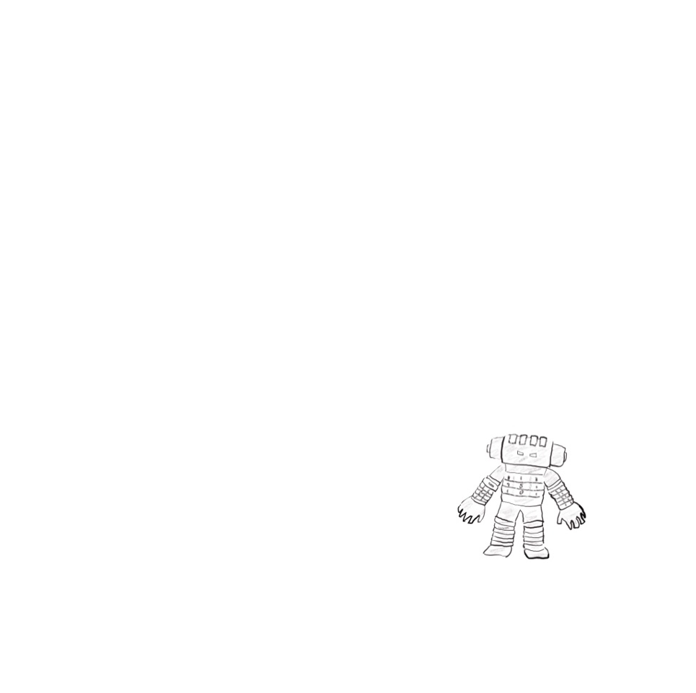

Grandpa was still going through the rest of the kit. “Hmm. No motor controller. No microcontroller. Without those, your robot isn’t going to walk or roll or do much of anything.”

I felt my excitement deflating.

Then he held up the white plastic block. “Ahhh…but this is a useful tool.”



“What is it?” I said.

“It’s called a breadboard.”

“A breadboard?”

“It’s for making circuits,” Grandpa said. “Back in the day, if an engineer wanted to prototype a circuit, he would screw components into a wooden bread-cutting board. Today we use these little plastic bricks instead, but we still call them breadboards.”

He kept going through the pile.

“You have a nice little assortment of resistors here,” he said.

He held up a piece that looked like this.



“And jumper wires.”



“And LED’s.”



“Looks like you also have a connector for a 9-volt battery, which will be helpful, and of course you’ve got the instruction booklet. You can read that if you’d like. I won’t need it.”

He tossed the instruction booklet aside.

“What can we build with all that?” I asked.

Grandpa ignored the question. “Tell you what, let’s make a deal.”

Classic Grandpa. His “deals” usually meant trading something I wanted—his wisdom, his tools, or occasionally cash—for something he wanted me to do, like chores, homework, or, one time, feeding his neighbor’s pet snake for a week.

“Before you can make a robot, you have to understand circuits.” He tapped the white plastic block, the one he’d called a *breadboard*. “This is the perfect place to start.”

“So what deal are we making?” I asked.

“You let me teach you about circuits, motors, and electronics, you do the hard work required to learn something new, and I’ll buy the parts you’re missing from this robot kit.”

This sounded like a pretty good deal to me.

“So I’m actually gonna be able to build a robot?” I said.

“In time,” said Grandpa. “But only if you promise to be patient. You have a lot to learn before you’re ready to just start making robots.”

“But I will be able to make one?”

“If you work hard enough, I don’t see why not.”

I was so excited, and at that moment, I was feeling like I’d lucked into the best $2 yard sale find ever.

I didn’t know it yet, but Dr. Kermit W. Sprocket had just dragged me into the adventure of my life.